PRODUCT REQUEST FORM
PRODUCT NAME: | Skin Marker
DESCRIPTION OF REQUEST:  - New Product  - Modification  - Product Extension  - Country addition  - Label Change  - Intended Use  -…Etc… | New Product under BU9 for US Allergy Clinics Market  Project Background  The U.S. allergy clinics market is significant and growing rapidly, with a valuation of $9.49 billion in 2024 and a projected CAGR of 7.5%, reaching $19.56 billion by 2034 (source: Grand View Research, 2024). Within this, the diagnostic consumables segment represents a substantial niche of $2.8–$3.5 billion, supported by well-defined clinical workflows.  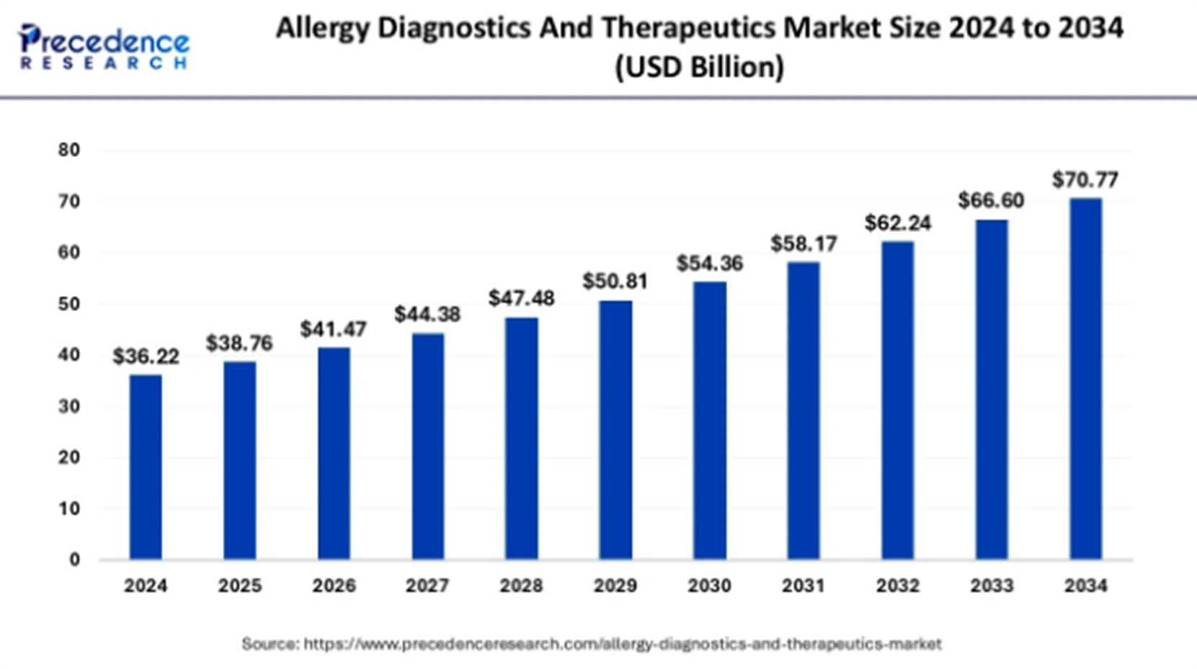  By establishing a "one-stop total solution" for Allergy Clinics Channel, we can engage more deeply across the entire allergy patient journey—from diagnosis (Skin Prick Tests, Blood Tests) to treatment (SLIT/SCIT) and ongoing management.  During the Skin Prick Test (SPT)—the gold standard for allergy diagnosis—clinicians require a skin marker to clearly delineate test sites on the patient's skin. By introducing our own compliant and optimized skin marker, we can complete the allergy diagnostic kit offering, increase account stickiness, and capture incremental revenue from a high-frequency, procedure-specific consumable.  Product Definition & Scope  Product: Skin marker. 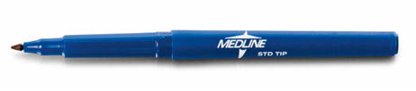  Primary Use: For preoperative or procedural skin marking in a clinical setting, specifically for marking test grids and sites during Allergy Skin Prick Testing.  Key Features (Based on Initial Specifications):  - Compliant Ink: Non-toxic, biocompatible ink meeting ASTM D4236 standard, safe for skin contact.  - Clear & Durable Marks: Formulated to resist smudging from antiseptic prep solutions (e.g., alcohol wipes) to maintain mark integrity throughout the 15-20 minute test period, aligning with AORN guidelines for clarity.  - Ergonomic Design: Fine tip (e.g., 0.5mm/1.0mm) for precision marking. Potential inclusion of a "15cm ruler" on the barrel to assist in maintaining the required ≥2cm spacing between test sites, directly addressing a key step in the SPT workflow.  - Regulatory Pathway: As a Class I device under 21 CFR § 878.4660, it is exempt from premarket notification (510k), enabling a faster time-to-market.
PURPOSE OF REQUEST: | ☐Complaint No. ☐Supplier ☒New market_______US_________  ☐Customer ___ ☐Internal _ ☐Other________________________  Add details:
ESTIMATED BENEFITS: | ☒ Financial Benefit: Complete the product lines for the allergy clinics markets, Annual sales amount 200K_ (Mandatory For NPD request)  Estimate the potential increase in cash flows, revenues, or any other financial benefits  ☐ Cost Saving:__________  Decrease in the cogs, transportation or operation expenses, or any other cost-saving opportunities  ☐ Improved Operational Efficiencies:_________  Decrease in the Lead time, delivery time, MOQ, Inventory, or any other efficiency improvement  ☐ Non-Financial Benefits:_________  Quality Improvement; Enhanced customer satisfaction, product competition, Brand reputation, etc.  ☐ Other Benefits:__________
PRODUCT DESCRIPTION:  - Functional performance requirements  - Appearance  - Any unique points of differentiation against similar competitor product lines  . ..Etc… | In compliance with US FDA regulations, skin marking pens are classified as Class I medical devices and are subject to general controls. They are exempt from pre-market notification but must meet the definitions and requirements outlined in 21 CFR § 878.4660.  Key Features:  Safe & Skin-Friendly Ink:  The ink complies with ASTM D4236 toxicity standards for art materials and demonstrates good biocompatibility. It is non-toxic and minimizes risks of skin irritation or allergic reactions.  Clear & Durable Markings:  Designed to provide distinct and long-lasting markings that resist smudging or fading during procedures. In line with AORN guidelines, markings remain clear and legible—suitable for initials, "YES" indicators, or incision lines—to avoid ambiguity during surgery.  Ergonomic Design:  Common market specifications include fine tip sizes of 0.5mm and 1.0mm, with pen lengths ranging from 138mm to 170mm and diameters from 9.5mm to 15mm. This ensures comfortable grip and precise control for healthcare professionals.  Some models feature an integrated 15cm ruler for convenient measurement and positioning.  This product meets essential regulatory, safety, and usability standards, supporting reliable and efficient use in clinical settings.
REQUEST TYPE | ☐LCR (Labelling Change Request)  Changes on the labels without changing the products  ☐SCR (Supplier Change Request)  Change applications initiated by Suppliers  ☐ECR (Engineering Change Request)  Existing products that SOLM is the legal manufacturer  Engineer changes that are not bringing new hazards/risks  ☐NPD (New Product Development)  Develop new innovative products that SOLM will be the legal manufacturer  Significant changes on existing products that may bring new hazards/risks or new intended use  Change products from outsourcing to SOLM to be the legal manufacturer  Development of VET/Component products  ☐SDP (SOLM Distributor Product)  New product introduction that SOLM will not be the legal manufacturer  No change on the product, no SOLM information on the labels  ☒SPP (SOLM Portfolio Product)  New product introduction that SOLM will not be the legal manufacturer  No change on the product, Add SOLM information on the labels  ☐Customized Product / Market  Purchased products that SOLM is not the legal manufacturer  Engineering change on products or new customized products requested by SOLM  New Market region requested by SOLM
TARGET MARKET: | ☒ US ☐ Canada ☐ EMEA ☐ UK ☐ Brazil ☐ Australia & New Zealand ☐ Other countries/regions, list:
TARGET USE: | ☒ Human Use  ☐ Animal Health | STERILE | ☐ YES  ☒ NO
VOLUME/SALES OPPORTUNITY: | Launch volume required: | Yr 1 estimate | Yr 2 estimate
CUSTOMER NOTIFICATION | Do we have any special quality agreement in place with customer which requires approval before implementing changes? ☐ YES ☒ NO  If Yes, please provide the customer's name and evidence.  Attach the customer confirmation GF-0083 at the end of the form.  Is notification to the customers needed after change project is closed? ☐ YES ☒ NO  Remark:  Example: change affect regulatory, performance, appearance, etc. Notification method.
LEGAL MANUFACTURER: | ☐ Sol-Millennium  ☒ Other: __________ | BRANDING | ☒ Sol-Millennium  ☐ Private Label
EXPECTED PRODUCT LAUNCH PERIOD: | ☒ < 1 year  ☐ 1-3 year  ☐ > 3 years | EXPECTED PRODUCT LIFE PERIOD: | 10 years
NAME AND DATE of REQUEST: | Alex Lu 2026/1/26

Business Case:
Expand the product range beyond the Allergy Syringe, providing Allergy Clinics with a comprehensive one-stop solution covering diagnosis, treatment, personal protection, disinfection and other application scenarios.

Product | COO | Medline Uni Price | Target Uni Price | Target Gross Margin | Annual consumption in US | Sol-M Forcast（10% ） | Est. Sale Revenue
Skin Marker | China | $0.84 | $0.65 | 35% | 3,000,000 | 300,000 | 195,000

